User Manual
Communication System

Document change log
Rev. | Date | Author | Pages | Description
0 | 2014-06-27 | Artur Scholz | All | Created
1 | 2014-12-23 | Artur Scholz | All | Major revision

Table of Contents
1 Introduction 3
2 Applicable and reference documents 4
3 Definitions and abbreviations 4
4 Specification 5
4.1 Absolute maximum ratings 5
4.2 Physical characteristics 5
4.3 Electrical characteristics 6
4.4 RF and interface characteristics 6
5 Interfaces 7
5.1 Mechanical interfaces 7
5.2 Electrical interfaces 8
5.3 Software interfaces 11
6 Design description 15
6.1 Hardware 15
6.2 Software description 19
6.3 Software implementation 19
7 Handling and storage 20
8 Experimental usage 21
8.1 Set up for testing 21
8.2 Test procedures 22
9 Operational usage 23
9.1 System integration 23
9.2 Operations procedures 24

Introduction
The LC-2301a Communication System is a half-duplex communication system for UHF band operation with radio output power of up to 31 dBm (>1 W). The output power, the frequency and the frequency separation are user-programmable, allowing large flexibility in operation. The main function of the device is the receiving of telecommands and sending of telemetry over the space link and exposing this to the UART interface. The space link implements ECSS/CCSDS telecommand and telemetry frames (namely, CLTUs and CADUs). The physical layer of the space link uses binary FSK modulation at a default data rate of 1200 bps (user-programmable). Further, a mechanism to support antenna deployment is included.

Features:
- CubeSat and CubeSat Kit compatible with PC/104 form factor
- Industrial temperature range
- RF output power up to 31 dBm
- ECSS/CCSDS frame protocol for telecommands and telemetry
- Transceiver completely programmable
- Binary FSK at 1200 bps
- Operates in the UHF band (amateur radio band)
- Includes provisions for antenna deployment

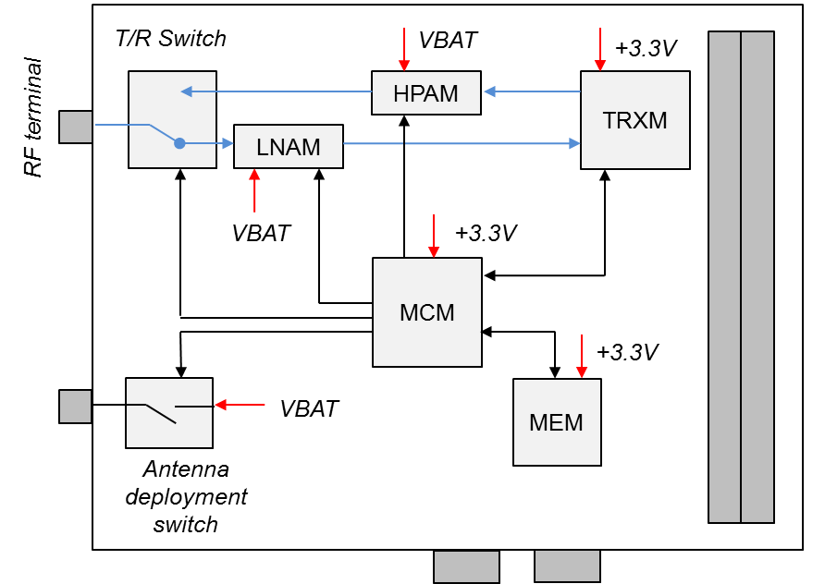Illustration 1: System block diagram

Applicable and reference documents

Reference | Title | Issue
AD01 | LibreCube Board Specification | 1

Definitions and abbreviations

Abbreviation | Definition
ASM | Attached sync marker
CCSDS | Consultative Committee for Space Data Systems
CLTU | Communications link transmission unit
ECSS | European Cooperation on Space Standardization
HPAM | High power amplifier module
LNAM | Low noise amplifier module
MCM | Microcontroller module
MEM | Memory module
MSB | Most significant bit
RF | Radio frequency
RSSI | Received signal strength indication
TC | Telecommand
TM | Telemetry
TNC | Terminal node controller
TRXM | Transceiver module
WPM | Words per minute

Specification

Absolute maximum ratings

Parameter | Min | Max | Unit
Operational temperature range | -40 | 85 | °C
Supply voltage on +3.3V |  | 3.6 | V
Supply voltage on VBAT |  | 4.5 | V

 | Exceeding the limits specified in the table above may result in permanent damage to the device and harm to products and personal.

Physical characteristics

Parameter | Min | Nom | Max | Unit
Total mass |  | 62.7 |  | g
Height above PCB |  |  | 5 | mm
Height below PCB |  |  | 9.6 | mm
PCB width |  | 95.9 |  | mm
PCB length |  | 90.2 |  | mm
PCB thickness |  | 1.6 |  | mm

Electrical characteristics

Parameter | Min | Nom | Max | Unit
Supply voltage on +3.3V | 3.0 | 3.3 | 3.6 | V
Supply voltage on VBAT* | 3.2 | 3.6 | 4.0 | V
Power consumption on +3.3V (idle) |  |  | 50 | mW
Power consumption on +3.3V (active) | 56 |  | 66 | mW
Power consumption on VBAT (active) | 1.2 |  | 4.2 | W
I2C node address (7 bit, hex) |  | 0x13 |  | -
I2C operating frequency |  | 50 | 100 | kHz
Microcontroller operating frequency |  | 6.125 |  | MHz
Measurement resolution |  | 12 |  | bit
UART baud rate |  | 9600 |  | bps
*VBAT powers the LNAM and the HPAM

RF and interface characteristics

Parameter | Min | Nom | Max | Unit
Antenna impedance (SMA connector) |  | 50 |  | Ohm
Centre frequency | 300 | 437 | 500 | MHz
Frequency programming steps |  | 250 |  | Hz
Frequency separation | 0 | 9.6 | 65 | kHz
Frequency sep. programming steps |  | 250 |  | Hz
RF baudrate |  | 1200 |  | bps
Transmit power | -17 |  | 31 | dBm
Receiver sensitivity (BER = 10⁻³) | -95 | -105 |  | dBm
Size of telecommand data buffer |  | 65536 |  | Byte
Size of telemetry data buffer |  | 65536 |  | Byte

Interfaces

Mechanical interfaces
The mechanical layout of the device is shown in Illustration 2. Four ø3.2 mm holes are located on the corners for mounting with M3 screws. The CubeSat connector is available in stack-through (as shown) and non-stack-through option.

Illustration 2: Mechanical layout

Electrical interfaces
All available connectors on the top and bottom of the board are shown in Illustration 3. Note that the arrow points to the location of pin 1 for each connector. The signals of each connector are described in Table 1 to Table 4.

Illustration 3: Connector layout
Table 1: Antenna deployment connector
Pin | Description
AD.1 | Connects to battery supply during deployment. Otherwise open.
AD.2 | Ground

Table 2: RF interface connector
Pin | Description
- | RF signal
- | Ground (shielding)

Table 3: Programming interface connector
Pin | Signal | Description
PI.1 | +3.3V | +3.3V power supply
PI.2 | TMS | JTAG TMS signal
PI.3 | TCK | JTAG TCK signal
PI.4 | TDI | JTAG TDI signal
PI.5 | TDO | JTAG TDO signal
PI.6 | GND | Ground.

The programming interface is used for updating the firmware.

Table 4: CubeSat connector
Pin | Signal | Description
H1.29 | -RESET | System reset line. Active low. Causes MCU to reboot.
H1.39 | TX0 | TX of UART0 for data to be transmitted via communication system.
H1.40 | RX0 | RX of UART0 for data received via communication system.
H1.41 | SDA0 | I2C system bus data
H1.43 | SCL0 | I2C system bus clock
H2.27, 28 | +3.3V | +3.3V power supply
H2.29, 30, 32 | DGND | Ground
H2.45, 46 | VBAT | Battery power supply (3.2 V – 4.0 V)

 | H1 |  |  |  |  | H2
 | 1 | 2 |  |  |  | 1 | 2
 | 3 | 4 |  |  |  | 3 | 4
 | 5 | 6 |  |  |  | 5 | 6
 | 7 | 8 |  |  |  | 7 | 8
 | 9 | 10 |  |  |  | 9 | 10
 | 11 | 12 |  |  |  | 11 | 12
 | 13 | 14 |  |  |  | 13 | 14
 | 15 | 16 |  |  |  | 15 | 16
 | 17 | 18 |  |  |  | 17 | 18
 | 19 | 20 |  |  |  | 19 | 20
 | 21 | 22 |  |  |  | 21 | 22
 | 23 | 24 |  |  |  | 23 | 24
 | 25 | 26 |  |  |  | 25 | 26
 | 27 | 28 |  |  | +3.3V | 27 | 28 | +3.3V
-RESET | 29 | 30 |  |  | DGND | 29 | 30 | DGND
 | 31 | 32 |  |  | AGND | 31 | 32 | DGND
 | 33 | 34 |  |  |  | 33 | 34
 | 35 | 36 |  |  |  | 35 | 36
 | 37 | 38 |  |  |  | 37 | 38
TX0 | 39 | 40 | RX0 |  |  | 39 | 40
SDA0 | 41 | 42 |  |  |  | 41 | 42
SCL0 | 43 | 44 |  |  |  | 43 | 44
 | 45 | 46 |  |  | VBAT | 45 | 46 | VBAT
 | 47 | 48 |  |  |  | 47 | 48
 | 49 | 50 |  |  |  | 49 | 50
 | 51 | 52 |  |  |  | 51 | 52
Illustration 4: CubeSat connector pin layout

Software interfaces
Interfacing for monitoring and control is accomplished via I2C bus. The device always operates as slave. A master can read and write the values of the internal registers of the device. The following paragraphs describe how to read and write the registers.

Write operation
The master initiates a write operation by issuing a START condition followed by the device’s slave address and a WRITE bit (0). When the master receives an ACKNOWLEDGE from the device it can transmit the 8-bit register address. The device will respond with a second ACKNOWLEDGE. The master then transmits the 8-bit value that shall be loaded into this register. The slave will respond with a third ACKNOWLEDGE. The write operation is then completed when the master issues a STOP condition or a second START condition.

S | Device Address | W | A | Register Address | A | Value | A | P

Read operation
The master initializes a read operation with a START condition followed by the device’s slave address and a WRITE bit (0). When the master receives an ACKNOWLEDGE from the device it can transmit the 8-bit register address. The device will respond with a second ACKNOWLEDGE. The master must then issue a new START condition followed by the device’s slave address and a READ bit (1). The sensor will respond with an ACKNOWLEDGE followed by the value of the register. The master must issue a NOT ACKNOWLEDGE followed by a STOP condition to terminate the operation.

S | Device Address | W | A | Register Address | A | S | Device address | R | A | Value | NA | P

Bit operations
The read and write operations operate on the basis of single bytes. In order to set or clear single bits from the internal register without changing the other bits of that register, the register must be first read out, then be subjected to AND/OR operation for clearing/setting a single or multiple bits, and finally the result must be written back to the register.

Device register
Writing and reading of the device registers allows full control and knowledge about the device. The content of the register is shown in Table 5. It is divided into segments that group related registers together.

Table 5: Device register
Add  (hex) | Register name | Default | Read / Write | Note | Segment
0x00 | null | - | - |  | Main
0x01 | cmd | - | W | Command input | Main
0x02 | hkperiod | 1 Hz | R/W | Sets HK period | Settings
0x03 | measure | All | R/W | Sets measurement mode | Settings
0x04 | tm_power | 26 dBm | R | FM transmit power | Settings
0x05 | frx_l | 436.850  MHz | R | Receive frequency | Settings
0x06 | frx_m | 436.850  MHz | R | Receive frequency | Settings
0x07 | frx_h | 436.850  MHz | R | Receive frequency | Settings
0x08 | ftx_l | 436.995  MHz | R | Transmit frequency minus half of frequency separation | Settings
0x09 | ftx_m | 436.995  MHz | R | Transmit frequency minus half of frequency separation | Settings
0x0A | ftx_h | 436.995  MHz | R | Transmit frequency minus half of frequency separation | Settings
0x0B | fsep_l | 9.6 kHz | R | Frequency separation | Settings
0x0C | fsep_h | 9.6 kHz | R | Frequency separation | Settings
0x0D | flag | - | R | System flags | Flags
0x0E | mcutemp_l | - | R | MCU temperature | Values
0x0F | mcutemp_h | - | R | MCU temperature | Values
0x10 | hpatemp_l | - | R | HPA temperature | Values
0x11 | hpatemp_h | - | R | HPA temperature | Values
0x12 | rssi_l | - | R | RSSI level | Values
0x13 | rssi_h | - | R | RSSI level | Values
0x14 | tc_byte_counter_l | - | R | Counter of received TC bytes | Values
0x15 | tc_byte_counter_m | - | R | Counter of received TC bytes | Values
0x16 | tc_byte_counter_h |  |  | Counter of received TC bytes | Values
0x17 | tm_byte_counter_l |  |  | Counter of transmitted TM bytes | Values
0x18 | tm_byte_counter_m |  |  | Counter of transmitted TM bytes | Values
0x19 | tm_byte_counter_h |  |  | Counter of transmitted TM bytes | Values

Table 6 provides detailed information about all of the not self-explanatory registers listed in Table 5. Each register is 8 bit, and as structured as shown below.

<register name>
Bit 7  MSB | Bit 6 | Bit 5 | Bit 4 | Bit 3 | Bit 2 | Bit 1 | Bit 0  LSB

Table 6: Detailed description of registers
Register | Description
cmd | Command input register. The following commands are defined:
  Opcode | Mnemonic | Description
  0x01 | RESET | Triggers a microcontroller reset.
  0x02 | MEASURE | Triggers a manual refreshment of measurements.
  0x03 | UPDATE_TRX | Updates the transceiver to the settings given in registers 0x08 to 0x0F.
  0x04 | DEPLOY_ANT | Powers the antenna deployment circuit for a fixed duration of one second.
  0x05 | TX_ENABLE | Enable the transmission of data over the space link.
  0x06 | TX_DISABLE | Disabled the transmission of data over space link.
hkperiod | Sets the refreshment cycle of measurements for the housekeeping data, in steps of 1/10 seconds. Set to zero to disable automatic refreshment.
measure | Defines which of the measurement types are updated when a measurement is triggered (manual or via automatic refreshment). Set or clear the following bits:  Bit 0: temperature  Bit 1: rssi
tm_power | Adjusts the RF output power of telemetry frames. Settings are not linear and must be calibrated. Changes have immideate effect.
frx_[l/m/h] | Receiver frequency setting.
ftx_[l/m/h] | Transceiver frequency setting.
fsep_[l/h] | Frequency separation setting.
flag | This register holds the flags of system events.
  Bit | Name | Description
  0 | busy | Flag is set when device is not idle, that is when doing measurements for the housekeeping, or transmitting/receiving data over the space link.
  1 | complete | Flag is set when the recent measurements for the housekeeping have completed.
  2 | sending_tm_data | This bit is set during the transmission of TM frame over the space link.
  3 | receiving_tc_data | This bit is set whenever the device has found the CLTU start sequence in the received space link, and is busy with processing the incoming frame.
  4 | antenna_deploying | This flag is set when the antenna deployment is ongoing.
  5 | rf_bitlock | Same as bit 3.
  6 | tx_enabled | This bit is set when TX is enabled.
  7 | tx_on | This bit is set when TX is on. Same as bit 2.
mcutemp_l/h | Contains low byte and high byte of temperature measurement code (at microcontroller). Convert to Celsius according to¹:  Temperature [Celsius] = gain * code + offset
hpatemp_l/h | Contains low byte and high byte of temperature measurement code (at HPA). Convert to Celsius according to¹:  Temperature [Celsius] = gain * code + offset
rssi_l/h | Contains low byte and high byte of RSSI measurement code. Convert to Celsius according to¹:  P[dBm] = gain * code + offset
¹ The values for gain and offset are determined during calibration.

Design description

Hardware

Transceiver module (TRXM)
The transceiver is a single-chip UHF transceiver IC (CC1000 from Texas Instruments). A block diagram of the chip is given in Illustration 5.

Illustration 5: Block diagram of CC1000 transceiver

The receiver part is built as a traditional super-heterodyne down-conversion receiver (Illustration 6). The incoming RF signal is amplified in the LNA and then fed into the mixer. The mixer takes the input frequency f_{IN} from the LNA and the frequency f_{LO} from the local oscillator (which is a voltage controlled oscillator tuned to a specific frequency as described later) and produces the sum and difference frequencies (and harmonics), f_{IN} + f_{LO} and f_{IN} – f_{LO} respectively. The CC1000 uses an intermediate frequency (IF) of 150 kHz, and to achieve low-side injection (where the digital output data will not be inverted as for high-side injection) the LO is tuned to f_{IN} – f_{IF}. The result is that the original FSK signal with centre frequency of f_{RF} is converted to a fixed centre frequency f_{IF}, while retaining the frequency deviation (e.g. ±5 kHz) between ‘0’ and ‘1’. The output of the mixer is band-pass filtered to remove f_{IN} + f_{LO} and reduce harmonics. This signal is filtered and amplified and then fed to the demodulator. The data and clock are provided at DIO and DCLK respectively. The data at DIO is valid at the rising edge of DCLK.

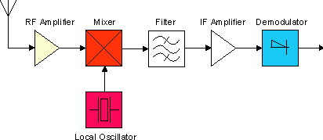Illustration 6: Concept of super-heterodyne receiver
During transmit mode the timing clock is provided at DCLK (whose frequency is defined by the baud rate setting). The data at DIO is latched at the rising edge of DCLK. The VCO signal is directly fed to the internal power amplifier (PA). The RF output is frequency shift keyed (FSK). The VCO is the f₀ frequency for a ‘0’ and f₀ + f_{SEP} is a ‘1’. The frequency separation f_{SEP} can be programmed in steps of 250 Hz. Illustration 7 pictures the relevant frequencies for receive and transmit mode.

Illustration 7: Frequency settings for TX and RX

The key blocks in the transceiver are described in the following in more detail.

The demodulator block samples the frequency and converts it to a voltage level. This level is (after quantization and filtering) compared to the value of the average filter to generate the data output. The average filter is used to find the average value of the incoming data.

The VCO uses an external inductor, which determines the operating range of the circuit. The tuning range limits can be tested as described in AN018 page 2. The frequency of operation should be ideally located somewhere near the center of this range.

The wide tuning range of a VCO is combined with an inherently high frequency stable crystal oscillator (XOSC) to do frequency synthesis in form of a phase-locked loop (PLL).

The phase detector compares the (R-divided) XOSC reference input with the feedback of the (N-divided) VCO and produces an error signal which is proportional to their phase difference. The error signal is then low-pass filtered (to remove AC variations and noise) and used to drive a VCO which creates an output phase. If the output phase drifts, the error signal will increase, driving the VCO phase in the opposite direction so as to reduce the error. Thus the output phase is locked to the phase at the reference input.

The matching of the RF input and output pins for the CC1000 is accomplished as described in the data sheet.

High power amplifier module (HPAM)
The fully matched (50 Ohm) high power amplifier IC provides high gain of 35 dB and an output power of P_{1dB} = 32.5 dBm. The power is taken directly from the battery supply to support the high current of I_{CC} = 1.3 A at maximum RF output. The PA gets very hot during operation and needs appropriate cooling in form of a large ground plane The PA block diagram is shown in Illustration 8. A current limiting IC is included in the supply line of the HPA to limit maximum current to about 1.3 Ampere, for safety reasons. The HPA is only powered when TX is enabled.

Illustration 8: Block diagram of HPA

Low noise amplifier module (LNAM)
A low noise amplifier IC is used to improve the signal quality of the received signal before going into the transceiver. The LNA is constantly powered.

Filter
The output of transceiver contains harmonics (integer multiples of the operating frequency), that should be filtered out before the power amplifier stage. A simple Pi-type low-pass filter as shown in Illustration 9 is utilized.

A band-pass filter to reject out-of-band signals at the receiver front-end is usually not necessary for space applications, as the problem of IDM (intermodulation distortion) or image noise is not dominant (because this would require other ground stations to actively transmit signals to the receiver system).

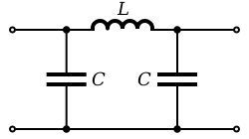Illustration 9: Pi-type low-pass filter

Duplexer
The duplexer is used for switching the antenna between the TX output and RX input of the transceiver, as the device only operates on a single frequency, and must therefore use half-duplex communication.

Antenna deployment module (ADM)
The antenna deployment module is simply a power switch that connects the VBATT voltage to the antenna deployment mechanisms (an external coil). A low-value resistor is inserted in the path to allow current limiting.

Memory module (MEM)
The memory module is a volatile SRAM, which us used as a buffer. It buffers a single beacon/frame coming in via the UART data bus before it is transmitted over the space link. It also buffers the received CLTUs coming from the space link.

Microcontroller module (MCM)
The microcontroller is a 8051 device. The MCU runs at 6.1256 MHz, which is enough for the baud rate of 1200 bps (high baud rate may require the MCU to run at higher speeds).

Software description

Functional overview
The functionality of the device is to:
- constantly search the incoming bit stream from the receiver for telecommands (in form of CLTUs), and buffer them
- route completely received telecommands to UART
- receive telemetry data from UART and send over the space link
- provide antenna deployment support
- produce housekeeping data

Software implementation

Main loop
Following initialization, the main loop checks for received commands (from a I2C master device) and periodically refreshes its housekeeping information (unless disabled). Then it looks if there are telecommand data bytes in the FIFO, and routes them to the UART, one byte per loop iteration. The last step of the loop is to check if there is telecommand data in the FIFO. If so, it will send it over the space link, one byte per loop iteration. It also takes care of activating TX at start of transfer and deactivation when the FIFO is emptied.

Telecommand reception
A timer (Timer 0) interrupt is triggered every 50 microseconds, which checks if a new bit has arrived. If so, this bit is shifted into a 16 bit buffer. This buffer is then compared to the CLTU start sequence (0xEB90). If it matches, a function for buffering the incoming CLTU is called. The structure of a CLTU is as shown:

CLTU – Command Link Transmission Unit
Start Sequence  0xEB90 | 1st  Codeblock | 2nd  Codeblock | ... | n-th  Codeblock | Tail sequence
2 byte | 8 byte | 8 byte |  | 8 byte | 8 byte

Valid tail sequence: 0xC5 0xC5 0xC5 0xC5 0xC5 0xC5 0xC5 0x79
or: 0x55 0x55 0x55 0x55 0x55 0x55 0x55 0x55

The device does not check any of the payload data for errors, it solely looks for the start sequence, incoming data, and finally the tail sequence, and pushes all of it in the telecommand FIFO buffer.

Note that CLTUs can have variable length, therefore the tail sequence is needed for detecting the end of each CLTU. However, there is a maximum allowed CLTU length defined in software, for the purpose of preventing a corrupted or lost tail sequence to cause a buffer overflow.

Telemetry transmission
For sending telemetry over the space link, an attached device simply needs to write the data to the UART connection. The data is received via the UART interrupt service routine byte for byte and added to the telemetry FIFO buffer.

Basically the telemetry data frame can have any structure and format, and hence any downlink protocol can be implemented by the master. Nonetheless, the device is supposed to use CCSDS telemetry frames, and therefore the data should be structured (as provided by the master device) as follows:

CADU – Channel Access Data Unit
Attached Synch Marker  0x1ACFFC1D | Data
4 byte | Fixed, max. 2048 byte

Note that telemetry frames (and hence CADUs), have a defined fixed length throughout the mission. This is needed in order to help the ground segment to synchronize.

Handling and storage
When handling the device make sure that it is powered off. To do so, disconnect all power lines from the device. For transportation put the device into an ESD protective bag and a box. For storage of the device ensure that it is in powered off. Store the device in an ESD protective bag in a dry, clean environment preferably at room temperature.

Be careful when making modifications to the board electronics. Avoid touching the board circuitry when handling. Mistreatment may result in damage.

Experimental usage

Set up for testing
- When setting up the device for in-lab operation, place it on a horizontal surface that is preferably covered by an ESD mat. Make sure that the device is powered off.

- Attach antenna to the device via a coax cable.

- Attach power supply cables to the 3.3V land VBAT pin. Alternatively, stack a power supply board (such as LC-2201a or similar) onto it. Make sure that at this step the device is not yet powered.

- To connect the device to a computer for monitoring and control use an I2C-UART bridge (LC-3101a or similar). Use the CubeSat board connector for connecting the SDA0, SCL0, +3.3V, and GND pins.

- To connect the device to a computer for transfer of data use a UART adapter (LC-3102a or similar). Connect the TX0, RX0, +3.3V, and GND pins from the device's CubeSat connector to the adapter. See Illustration 10.

- Power the device by switching on the external power supply.

Illustration 10: In-lab set-up (power supply not shown)

Test procedures

Reading from the device via I2C bus
For example, to read the housekeeping setting of the device, send the following two bytes via the terminal program: 0x27 0x02. The first byte is the device 7 bit I2C address appended by 1 bit for the read operation. The second byte is the register address from which to read. The device will respond with the default value of 0x0A.

Writing to the device via I2C bus
As another example, to set the housekeeping refresh rate to every 2 seconds, send the following: 0x26 0x02 0x14. The first is the 7 bit I2C address shifted to left one bit, followed by the register address, and the value to be written (20 decimal).

Sending telemetry
To send telemetry, simply write data to the TX0 port of the CubeSat board connector.

Receiving telecommands
When valid telecommands (i.e. CLTUs) are received, they are automatically routed to the RX0 port at the CubeSat board connector.

Operational usage

System integration

Mating with other boards
To integrate the device into a satellite it can be stacked onto other electronic boards that comply with the CubeSat connector layout. Use M3x15 mm spacers between the boards. (If such a stacked configuration is not feasible or desired, another option would be to route the electrical signals from the CubeSat connector via harness to the other subsystems.)

Make sure that all devices are powered off during mating.

Before mating the device with other boards make sure that the electrical connections are compatible with each other and remain within their specified levels at all times.

Antenna attachment
Connect a 50 ohm antenna for UHF band to the SMA terminal of the device via a 50 ohm coaxial cable. If the antenna or cable is not properly matched to 50 ohm, attenuation will be introduced. In case of excessive mismatch this may result in damage to the transmitter.

Always make sure that a 50 Ohm antenna (or dummy load) is properly connected to the device before operation.

Antenna deployment mechanism attachment
An antenna deployment circuitry is implemented on the device that essentially consists of an active low switch, controlled via the device’s register. When the switch is activated, the antenna deployment positive terminal will be connected to VBAT, which may be used to active an external antenna deployment mechanisms (such as melting a wire or releasing a hook).

Operations procedures

Control and monitoring
For control and monitoring of the device, the device’s registers are used as described in section 5.3. To achieve this, an external controller (on board computer) must operate on the I2C bus to read and write the registers of the device.

Housekeeping
The device periodically captures housekeeping data and updates the corresponding registers at periods defined in the hkperiod register. This function can be disabled. A manual triggering of housekeeping capture can be triggered via command. The housekeeping data consists of analog measurements and status bits as described in the next section. The measure register defines which measurements to update.

Measurements
The device provides two types of measurements. Temperature measurements from MCU and HPA are available. The locations are shown in Illustration 11. The RSSI measurement provides an indication on the strength of a received signal.
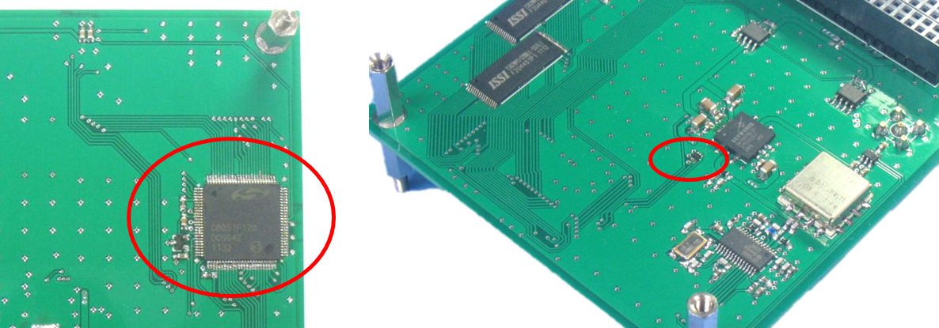Illustration 11: Location of temperature measurements

Sending telemetry
Same as Section 8.2.3.

Receiving telecommands
Same as Section 8.2.4.

Antenna deployment
Send the relevant command to the device via the I2C bus.

